Calculating Ground-State-Energy of $LiCoO_{2}$ by using Fragment molecular orbital-based Variational Quantum Eigensolver
Yoonho Choi¹ and Doha Kim¹, Doyeon Kim¹
¹ Department of Applied Physics, Hanyang University, Ansan, 15588, Republic of Korea
cyh195535@hanyang.ac.kr
Abstract. Variational Quantum Eigensolver (VQE) is a quantum computer algorithm that calculates the ground state energy and is highly anticipated to be effective in the development of new materials, such as in the field of drug and battery development. However, current quantum computers are limited in the number of qubits they can use, which limits the application of VQE to molecules used in industry. To solve this problem, this study proposes the use of FMO/VQE. The Fragment Molecular Orbital (FMO) method divides the whole system into small fragments for processing. FMO/VQE is a method that applies the FMO method to VQE.[1] In this study, to demonstrate the effectiveness of FMO/VQE, the ground state energy of $LiCoO_{2}$, which is used as the anode material of a secondary battery, was calculated using FMO/VQE. By doing so, the number of qubits required by the conventional VQE algorithm was reduced from 24 to a maximum of 14. Nevertheless, almost the same accuracy (99.989%) as the results obtained by the classical method was obtained. This study shows that the proposed VQE algorithm can be successfully applied in the field of battery and drug discovery.
Keywords: VQE, Quantum Computing, Lithium-ion batteries
- Introduction
The ground state of a molecule and its energy are the most stable state and lowest energy that a molecule can have. Knowing this information can be used to understand the bonds between molecules and the structure of molecules, which can be used in various fields of chemical research, such as the development of new drugs or new anode materials for secondary batteries. Currently, the ground state energy of a molecule is mostly calculated on classical computers. However, when the number of atoms in a molecule increases or the atomic number of the atoms in a molecule is large, the number of particles to be considered increases, and the interactions of each particle to be considered increase exponentially. The interactions of each particle are considered in the Hamiltonian of the molecule, and representing this molecular Hamiltonian on a computer requires a large amount of memory and computation. Therefore, calculating the ground state energy of a molecule using a classical computer is difficult to apply to large molecules.
Quantum computers are a recently emerging field, and there is a lot of research going on. Quantum computers use different qubits than classical computers, i.e., quantum bits, which are qubits with superposition of 0 and 1 states, unlike bits that represent only 0 and 1 in classical computers. This is why, in calculating the ground state energy of a molecule, when the number of particles increases and the memory required doubles, a quantum computer can do the calculation with one more qubit. Where a classical computer would require an exponential increase in memory, a quantum computer can solve with a polynomial increase in qubits. Therefore, even large molecules that are currently incomputable can be computed by quantum computers. The quantum computer algorithm Quantum Phase Estimation (QPE) is an algorithm that calculates the eigenvalues and eigenstates of a unitary matrix on a quantum computer, which can be used to find the ground state energy of a molecule. However, QPE is known to be very accurate and requires many qubits to implement. Current quantum computers are said to be at the level of noisy intermediate-scale quantum devices (NISQs). NISQ means that the quantum computer is noisy and has intermediate-scale qubits. Current quantum computers are still noisy and lack accuracy, and the number of qubits is still low, in the tens or hundreds, making it difficult to implement QPEs.
Variational Quantum Eigensolver (VQE) is an algorithm for solving eigenvalue problems using these NISQ-level quantum computers, which uses both quantum and classical computers. VQE uses variational principles to construct a parameterized trial wave function to obtain the basis of the molecular Hamiltonian. The algorithm iterates by adjusting the parameters until this basis value converges to a constant value to obtain an upper bound on the ground state energy of the molecule. In this process, the molecular Hamiltonian and the test wavefunction are replaced by quantum circuits, and the process of obtaining the expectation value is performed by a quantum computer, and the optimization process of adjusting the parameters of the test wavefunction is performed by a classical computer. Unlike QPE, VQE does not require many qubits, and the optimization that is difficult for current quantum computers is calculated by a classical computer, so there are many expectations that quantum computers can be commercialized in the NISQ era. However, current quantum computers have too many errors, their accuracy decreases significantly as the circuit depth increases, and the number of qubits available is limited, which is insufficient to calculate very large molecules.
Therefore, one of the various methods to solve this problem is the Fragment Molecular Orbital method based Variational Quantum Eigensolver (FMO/VQE). FMO/VQE was first devised by Hocheol Lim, et al. as an algorithm that applies the FMO method, a quantum chemistry method, to VQE to improve the limitations of VQE due to the limitations of current quantum computers. The FMO method approximates the ground-state energy of the whole molecule by dividing the whole system into small pieces, and then finds the ground-state energy of the small pieces (monomer) and the pair of small pieces (dimer) and uses them to approximate the ground-state energy of the whole molecule. By breaking the molecule into smaller pieces, the maximum size of the system that needs to be considered in the overall calculation can be reduced, and this can be applied to VQE to reduce the number of cubits required and the depth of the quantum circuit. Therefore, FMO/VQE is expected to be a way to utilize quantum computers in the near future.
In this paper, we use FMO/VQE to calculate the ground state energy of LiCoO2, a representative material used as an anode material for secondary batteries, and compare it with classical computer calculations. We also compare the accuracy of FMO/VQE with classical VQE to confirm the feasibility of FMO/VQE in the NISQ era.
- Method
  - Lithium-ion battery
Lithium-ion batteries are one of the secondary batteries used in various industries. A lithium-ion battery consists of an anode material, a cathode material, and an electrolyte, where lithium oxide is used as the anode material. This compound has a layered structure of $CoO_{2}^{-}$oxide, with $Li^{+}$ions bonded between each layer. The energy charge depends on the degree to which the lithium ions are oxidized in the oxide. Lithium is known to have a limited number of reserves in the world. Many methods have been proposed as solutions to this problem, one of which is an approach that seeks to maximize the energy charged per lithium ion. This is a critical situation, both in terms of lithium reserves and in terms of battery miniaturization. To calculate the amount of energy stored per lithium, it is essential to calculate the ground state of the molecule. However, this calculation is classically performed, and the ability to calculate larger molecules or more diverse combinations is limited. In this study, we show the results of applying the VQE algorithm to LiCoO2 molecules and demonstrate the applicability of quantum computers in the field of battery development.
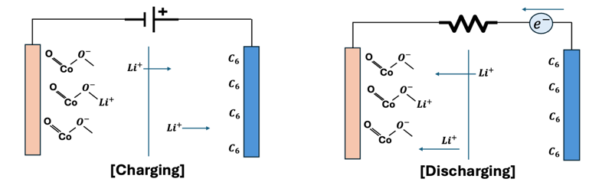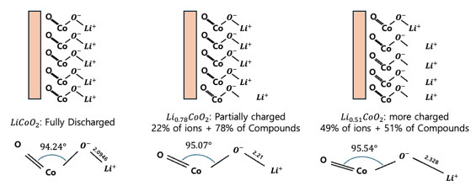
Fig. 1. Left) Schematic of battery charging and discharging, Right) Geometry of compounds by oxidation state
When a voltage is applied to the anode and cathode to supply electrons (i.e., charging), the $Li^{+}$ions migrate to the cathode. When discharged from this charged state, the $Li^{+}$ions from the negative electrode are recombined with the positive electrode, as shown in the figure below, and current flows through the resistor. At this time, depending on the oxidation state of lithium, the average geometry of the molecular structure changes as shown in Fig.1. so, the energy in the bulk can be estimated using the geometry. The energy of the molecule is calculated by assuming the gas-phase model, which considers the average oxide structure as a single molecule.
  - VQE(Variational Quantum Eigensolver)
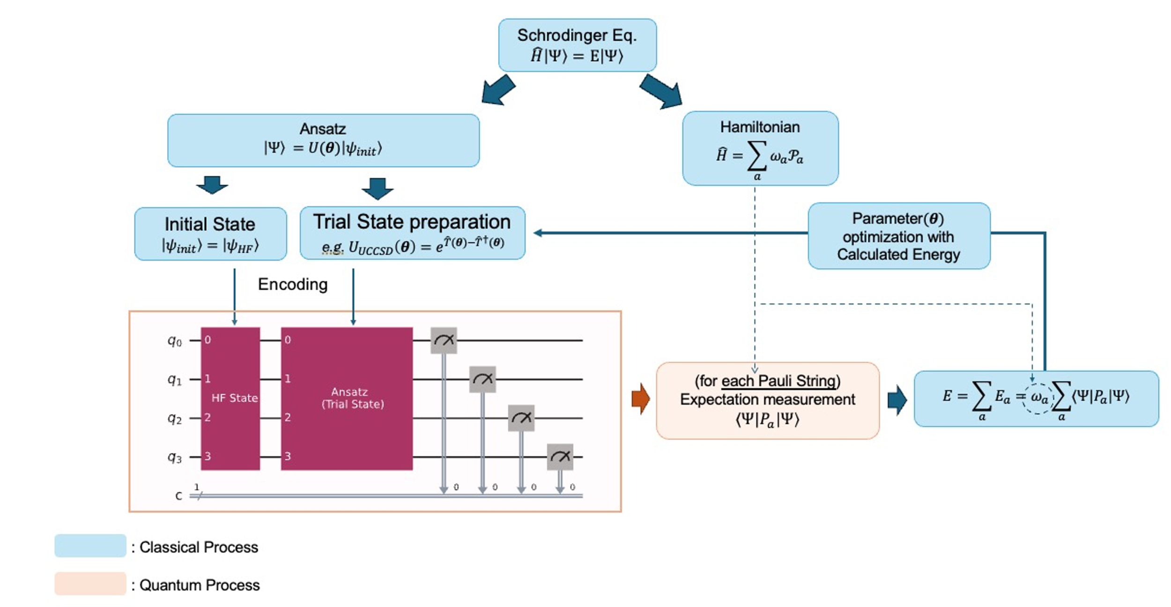
Fig. 2. VQE Pipeline
The VQE algorithm is an eigenvalue problem solving algorithm first proposed by Peruzzo et al. in [2] that works by computing the energy in Hilbert space that provides an upper bound on the ground state energy according to the variational principle. VQE computes the ground state energy of a system by measuring the energy on a quantum computer and performing optimization on a classical computer. To measure the energy of a system on a quantum computer, we need to map the Hamiltonian to a foliate, represent an arbitrary quantum state, and encode it in a quantum circuit.

Hamiltonian
The Hamiltonian of a molecule is represented by the Electronic Structure Hamiltonian as shown below.
${\hat{H}}_{el}(r)=-\sum_{i}{\frac{1}{2}∇_{r_{i}}^{2}-\sum_{I}{\sum_{i}{\frac{Z_{I}}{\left|R_{I}-r_{i}\right|}}}}+\sum_{i}{\sum_{j>i}{\frac{1}{\left|r_{i}-r_{j}\right|}}}$ (1)
(where $r_{i}$denotes the position vector of the $i^{th}$ electron, $R_{I}$ denotes the position of the ith nucleon, and $Z_{I}$ is the atomic number of the $I^{th}$ nucleon). To map this Hamiltonian to the Pauli gate, we write it in second quantized form, which is expressed through the fermionic creation/annihilation operator as follows
${\hat{H}}_{el}=\sum_{p,q}{h_{pq}{\hat{a}}_{p}^{†}{\hat{a}}_{q}}+\frac{1}{2}\sum_{p,q,r,s}{h_{pqrs}{\hat{a}}_{p}^{†}{\hat{a}}_{q}^{†}{\hat{a}}_{r}{\hat{a}}_{s}},$ (2)
$where, h_{pq}=\left\langle ϕ_{p}\left|{\hat{H}}_{el}\right|ϕ_{q}\right\rangle , h_{pqrs}=\left\langle ϕ_{p}ϕ_{q}\left|{\hat{H}}_{el}\right|ϕ_{r}ϕ_{s}\right\rangle$ (3)
Fermionic operators can be mapped to Pauli gates using Jordan-Wigner mapping, Parity mapping, and bravyi kitaev mapping. In this experiment, we will use the Parity mapping method. Parity mapping expresses the creation/annihilation operator through a Pauli gate by corresponding the parity of the $i^{th}$ qubit to the parity of the electron occupancy of the $i^{th}$orbital. In this case, the parity of the α-spin β-spin of the molecule can be utilized to reduce the number of qubits required by two. The resulting Hamiltonian of the mapping is represented by a Pauli string ($P_{a}$) and its weights or linear coefficients ($ω_{a}$) as shown below.
$\hat{H}=\sum_{a}{ω_{a}P_{a}}$ (4)

Ansatz
To represent arbitrary quantum states, we construct a parameterized quantum circuit (PQC) with linear coefficients corresponding to each basis as parameters. The performance of the ansatz is difficult to evaluate, and it is in the a priori domain that it is not known which ansatz is better for different systems. Therefore, in this experiment, we use two different ansatzes to get better results.

Two-Local (Efficient SU2) Ansatz
The quantum state of a single qubit is represented by a rotation gate for two arbitrary angles on a Bloch sphere. If the angle of the rotation gate is a parameter, and the entanglement, which is the property of a qubit in a multi-qubit system, is expressed using a CNOT gate, the quantum state of an arbitrary multi-qubit system can be expressed using parameters.
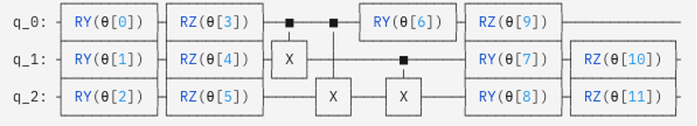
Fig. 3. Two_Local Ansatz Example on a 3-Qubit System

The construction of the Two-Local Ansatz does not involve a Hamiltonians interpretation. It is a representation of an arbitrary quantum state that is represented in hardware and is therefore hardware efficient.

UCCSD Ansatz
Through the second quantization, we express the Hamiltonian operator as the basis of the molecular orbitals of the system. In the end, the state we are looking for is expressed in the same Hilbert space as the Hamiltonian, so using the same spinorbit as the basis, we can express any quantum state in the Hilbert space where the Hamiltonian exists. In this way, the quantum state is expressed through Coupled-Cluster Theory using the spin-orbit wavefunction of the molecule as the basis, and considering only the 2nd-order excitation, it is expressed as a unitary one, UCCSD (Unitary Coupled Cluster Singles and Doubles), and the expression is as follows.
$\hat{T}={\hat{T}}_{1}+{\hat{T}}_{2}, \left(Cluster operator\right)$ (5)
$where, {\hat{T}}_{1}=\sum_{i,a}{c_{i}^{a}{\hat{a}}_{a}^{†}{\hat{a}}_{i}}, {\hat{T}}_{2}=\sum_{ijab}{t_{ij}^{ab}{\hat{a}}_{a}^{†}{\hat{a}}_{b}^{†}{\hat{a}}_{j}{\hat{a}}_{i}}$
${\left|Ψ\right\rangle }_{UCCSD}=e^{\hat{T}-{\hat{T}}^{†}}\left|ψ_{ref}\right\rangle$ (6)
The states are represented by creation and destruction operators, which can be encoded in quantum circuits via Jordan-Wigner mapping or parity mapping.
The energy of the system is calculated by measuring the expectation value for each Pauli string in the Hamiltonian for these quantum circuits. By iterating over these measurements and optimizing the parameters of the ansatz so that the calculated energy is minimized, an upper bound on the ground state energy is found. The resulting minimum corresponds to the ground state energy calculated by the VQE algorithm for the system.
  - FMO(Fragmental Molecular orbital)
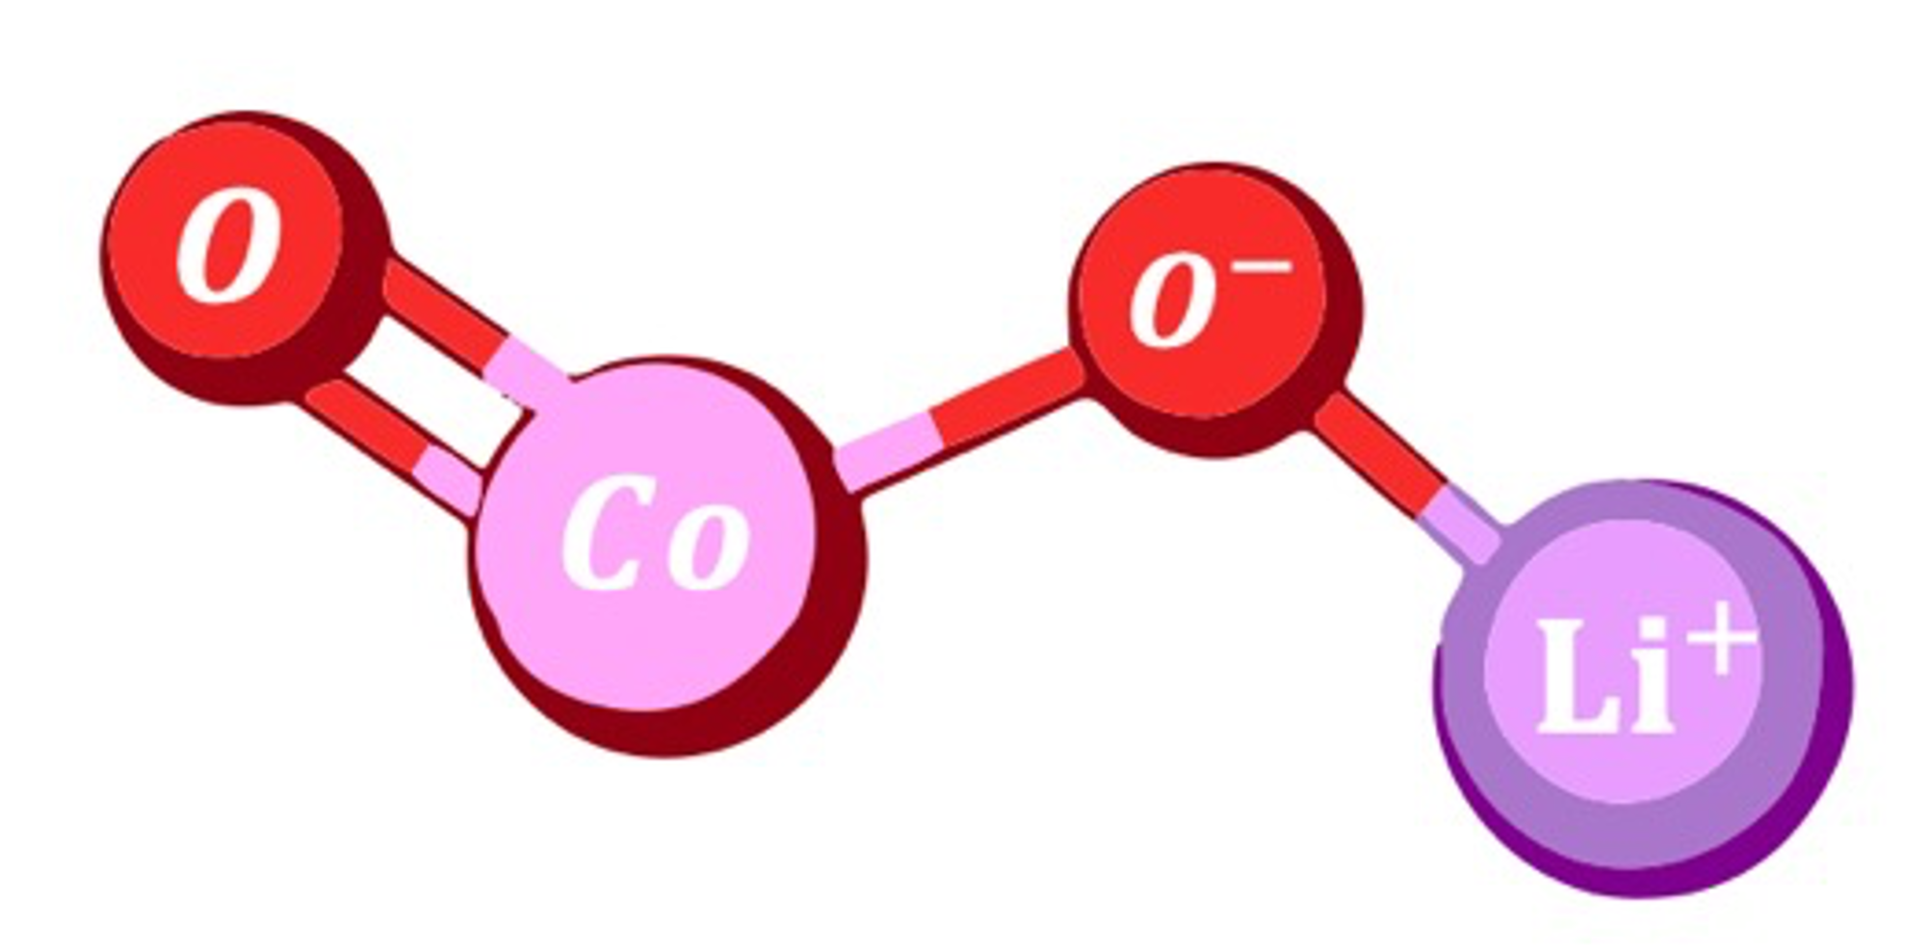
Fig. 4.
The FMO method is a method that divides a whole molecular system into smaller system fragments and approximates the energy of the whole system by using the energy of one fragment (monomer) and the energy of pairs of fragments (dimers). When calculating the ground state energy of a molecule by the usual method, the computational complexity is exponential in the size of the system. However, the FMO method can effectively reduce the computational complexity by dividing a large system into parts.
The FMO method has two main steps. The first is the FMO-based restricted Hartree-Fock (FMO-RHF) process, which calculates the RHF through the Hamiltonian of monomers and dimers. The Hamiltonian of monomer(${\hat{H}}_{A}$) and the Hamiltonian of dimer(${\hat{H}}_{AB}$) are as follows.
${\hat{H}}_{A}=\sum_{i∈A}{\left[-\frac{∇_{r_{i}}^{2}}{m_{e}}-\sum_{I}{\frac{Z_{I}}{\left|r_{i}-R_{I}\right|}}+\sum_{ C≠A}^{N_{tot}}{∫dr^{'}\frac{ρ_{J}\left(r^{'}\right)}{\left|r_{i}-r^{'}\right|}}\right]}+\sum_{i∈A}{\sum_{i<j∈A}{\frac{1}{\left|r_{i}-r_{j}\right|}}}$ (7)
${\hat{H}}_{AB}=\sum_{i∈A,B}{\left[-\frac{∇_{r_{i}}^{2}}{m_{e}}-\sum_{I}{\frac{Z_{I}}{\left|r_{i}-R_{I}\right|}}+\sum_{C≠A,B}^{N_{tot}}{∫dr^{'}\frac{ρ_{J}\left(r^{'}\right)}{\left|r_{i}-r^{'}\right|}}\right]}+\sum_{i∈A,B}{\sum_{i<j∈A,B}{\frac{1}{\left|r_{i}-r_{j}\right|}}}$ (8)
(Where A,B are the respective fragments. C refers to the fragments that are not included in monomer A or dimer AB, and the term $ρ_{J}\left(r^{'}\right)$ is the electric charge density of the fragments outside the monomer or dimer.) By calculating the RHF of each monomer and dimer through the Hamiltonian above, we can get $E^{FMO-RHF}$, which can be expressed as follows.
$E^{FMO2-RHF}=E^{FMO1-RHF}+ΔE^{FMO2-RHF}$ (9)
$E^{FMO1-RHF}=\sum_{A}^{N}{E_{A}}$ (10)
$ΔE^{FMO2-RHF}=\sum_{A>B}^{N}{\left[E_{IJ}-E_{I}-E_{J}\right]}$ (11)
In the above equations, N refers to all fragments. From the above equations, we can get the HF energy including the electrostatic potential of the whole molecule. The next step is to proceed with FMO based coupled-cluster (FMO-CC). This process is performed to obtain a more accurate value of the FMO-RHF energy, and since this process does not include the electrostatic potential, the Hamiltonian can be calculated using the Electronic Structure Hamiltonian defined earlier. The process of calculating the total energy ($E^{FMO-CC}$) and correlation energy ($E^{FMO-corr}$) obtained through FMO-CC is as follows.
$E^{FMOn-CC}=E^{FMOn-RHF}+E^{FMOn-corr}$ (12)
$E^{FMO2-corr}=E^{FMO1-corr}+ΔE^{FMO2-corr}$ (13)
$E^{FMO1-corr}=\sum_{A}^{N}{E_{I}^{corr}}$ (14)
$ΔE^{FMO2-corr}=\sum_{A>B}^{N}{\left(E_{IJ}^{corr}-E_{J}^{corr}-E_{I}^{corr}\right)}$ (15)
In the above, the FMO-RHF and FMO-CC processes should be separated because the Hamiltonian used in the two processes may be different, and the FMO-CC process should proceed after the SCF calculation of FMO-RHF converges. However, in this experiment, the electrostatic potential term in the FMO-RHF Hamiltonian was approximated by ignoring it, so each process was carried out consecutively and the total energy was calculated from the obtained monomer and dimer energies as follows.
  - FMO/VQE (Fragment molecular orbital-based Varational Quantum Eigensolver)
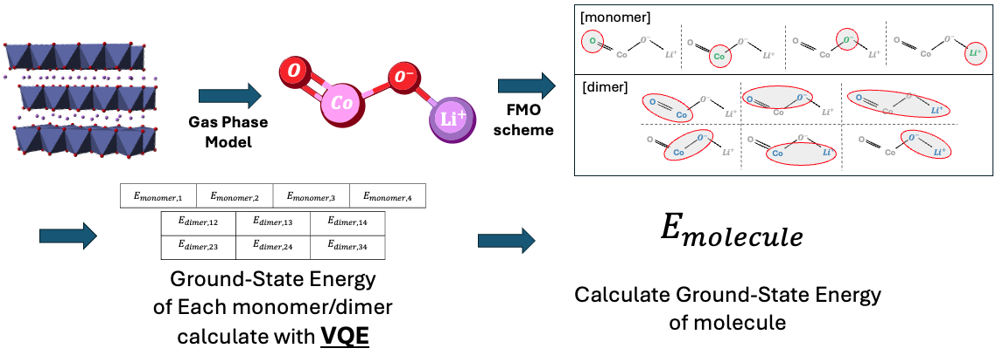
Fig. 5.
FMO/VQE is an algorithm first introduced by Hochel Lim et al. that combines the VQE algorithm with the FMO method. In the VQE algorithm, the Hemiltonian is represented based on the molecular spinorbitals, so it requires as many qubits as the number of molecular spinorbitals. However, the number of qubits is currently limited, so the number of molecules that can be simulated in the existing VQE algorithm is limited. However, if the FMO Method is applied to the existing VQE algorithm, the number of qubits required for a single calculation can be reduced by parallelizing the calculation and simulating the total system in pieces.
Let's compare the number of qubits required with and without the FMO method. Both calculations use Active Space to reduce the number of qubits required. Given the dynamics of the system, excitations in the core orbital of each atom will have a smaller probability than excitations in the valence orbital. Therefore, we will calculate the core orbital, which is less likely to be involved in bonding, as a separate constant, and assume that the space spanned by the wavefunction of the valence orbital of each atom is a Hilbert space. Under these assumptions, the number of qubits required for a conventional VQE calculation is as follows.
Table 1.
atom | Number of Valence orbital | Number of Valence electron
$$Li$$ | 2 | 1
$$O$$ | 6 | 8
$$Co$$ | 10 | 7

Therefore, the number of spinorbitals required for the VQE calculation is 24, considering that oxygen has 2. If we use the parity mapper here, we can reduce the number of qubits needed for the calculation by 2, so 22 qubits are needed to solve this system via conventional VQE.
Let's apply the FMO method, where each atom is a fragment, which means that 4 monomers are created and 6 dimer systems need to be calculated. The number of spin-orbitals required for each calculation is shown below (only one is shown for configurations with the same composition).
Table 2.
Configuration | Number of Valence orbital | Number of Valence electron
monomer
$$Li$$ | 2 | 1
$$O$$ | 6 | 4
$$Co$$ | 10 | 7
Dimer
$$Li-O$$ | 6 | 5
$$Li-Co$$ | 12 | 8
$$O-O$$ | 12 | 8
$$Co-O$$ | 16 | 11

Therefore, the maximum number of qubits required in the calculation is 14 (using Parity mapper). By applying the FMO method, we can reduce the number of qubits required for the calculation by 8. Furthermore, the potential of this method is in larger systems. When simulating larger molecules such as Ni, Mn, etc. added to the popular $LiCoO_{2}$ molecule, conventional VQE requires more qubits than the number of valence orbitals of those atoms. However, in FMO/VQE, the increase in the size of the system leads to an increase in the number of fragments, so it is possible to calculate the energy of larger molecules using the same number of qubits.
- Result

[x=1] | UCCSD |  |  | Two-Local
Configuration | COBYLA | SPSA | L-BFGS-B | COBYLA | SPSA | L-BFGS-B
“Li-O¹” | -81.036530 | -81.062982 | -81.069739 | -81.023626 | -80.978418 | -81.069703
“Li-O²” | -81.117531 | -81.117951 | -81.117956 | -81.094238 | -81.030553 | -81.117577
“Li-Co” | -1373.429758 | -1373.567946 | -1373.618739 | -1373.576316 | -1373.512522 | -1373.609970
“O-O” | -147.432250 | -147.485749 | -147.599156 | -147.528891 | -147.334234 | -147.605860
“Co-O¹” | -1439.355819 | -1439.796790 | -1439.957262 | -1439.315189 | -1439.321781 | -1439.695408
“Co-O²” | -1439.459214 | -1439.788926 | -1439.888880 | -1439.396154 | -1439.727786 | -1439.918488

  - Monomer Energy
  - Dimer Energy
  - Molecular Energy
- Conclusions
The quantum algorithm FMO/VQE proposed in this study was able to calculate the ground state energy of LiCoO_2 molecules with an accuracy of 99.989% compared to the classical simulator. This result demonstrates the applicability of the FMO/VQE method to future drug synthesis and new material development. Classical computing methods are unable to calculate the complex molecules required for drug synthesis and new material development.
The FMO/VQE algorithm proposed in this study reduces the number of qubits required for computation by using the FMO method, which makes it possible to solve molecules that are difficult to compute using quantum computers using VQE. These results show that the FMO/VQE algorithm can be a new paradigm in the field of drug synthesis and new material development where complex molecules need to be calculated.

References
- Hocheol Lim, et al., Fragment molecular orbital-based variational quantum eigensolver for quantum chemistry in the age of quantum computing, Scientific Reports 14, 2422 (2024)
- Peruzzo A., et al., A variational eigenvalue solver on a photonic quantum processor, Nature Communications 5, 4213 (2014)
- Jules Tilly, et al. The Variational Quantum Eigensolver: A review of methods and best practices, Physic Reports 986, 1-12 (2022)
- J.T.Hertz et al. Magnetism and structure of $Li_{x}CoO_{2}$ and comparison to $Na_{x}CoO_{2}$, Department of Chemistry, Princeton University, DOI: 10.1103/PhysRevB.77.075119
- Kazuo Kitaura, et al., Fragment molecular orbital method: an approximate computational method for large molecules, Chemical Physics Letters 313, 701-706 (1999)
- Dmitri G. Fedorov, Kazuo Kitaura, Coupled-cluster theory based upon the fragment molecular-orbital method, The Journal of Chemical Physics 123, 134103 (2005)
- Stewart, Robert F. (1 January 1970). "Small Gaussian Expansions of Slater‐Type Orbitals". The Journal of Chemical Physics. 52 (1): 431–438. doi:10.1063/1.1672702.

  - A Subsection Sample
Please note that the first paragraph of a section or subsection is not indented. The first paragraphs that follows a table, figure, equation etc. does not have an indent, either.
Subsequent paragraphs, however, are indented.

Sample Heading (Third Level). Only two levels of headings should be numbered. Lower level headings remain unnumbered; they are formatted as run-in headings.

Sample Heading (Forth Level). The contribution should contain no more than four levels of headings. The following Table 3 gives a summary of all heading levels.
Table 3. Table captions should be placed above the tables.
Heading level | Example | Font size and style
Title (centered) | Lecture Notes | 14 point, bold
1st-level heading | 1 Introduction | 12 point, bold
2nd-level heading | 2.1 Printing Area | 10 point, bold
3rd-level heading | Run-in Heading in Bold. Text follows | 10 point, bold
4th-level heading | Lowest Level Heading. Text follows | 10 point, italic
Displayed equations are centered and set on a separate line.
x + y = z (16)
Please try to avoid rasterized images for line-art diagrams and schemas. Whenever possible, use vector graphics instead (see Fig. 6).

Fig. 6. A figure caption is always placed below the illustration. Short captions are centered, while long ones are justified. The macro button chooses the correct format automatically.
For citations of references, we prefer the use of square brackets and consecutive numbers. Citations using labels or the author/year convention are also acceptable. The following bibliography provides a sample reference list with entries for journal articles [1], an LNCS chapter [2], a book [3], proceedings without editors [4], as well as a URL [5].

